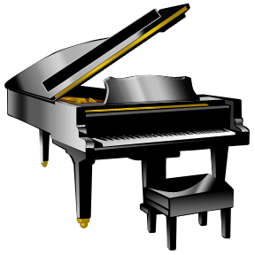
Student Repertoire List 2011 Name: ______________________
Aim = 40 pieces a year!
# | Title of Piece | Composer (if known) | Started + Date
1
2
3
4
5
6
7
8
9
10
11
12
13
14
15
16
17
18
19
20
21
22
23
24
25
26
27
28
29
30
31
32
33
34
35
36
37
38
39
40!

